|  |  |
| --- | --- |
| prototype  Assignment 1 | Jade Watermeyer 1840965. Matthew Brown 1860489. Keagan Bowler 1973457. Zayaanah Albertyn 1827429. Ben van den Heever 1940463.  WSOA3004 |

Contents

Group members 2

Project manager 2

Designer 2

Programmer 2

Writer 2

Sound 2

Game overview 3

Concept 3

Genre 3

Target audience 3

Game flow summary 3

Game Layout 4

Gameplay 4

Progression 4

Mission/challenge structure 4

Objective 5

Mechanics 5

Movement 5

Objects 5

Actions 1

Story 1

Interface 1

Visual system 1

Audio, music, sound effects 1

UI 1

Game images 3

Credits 3

Outcome 4

Communication 4

Discord 4

WhatsApp 5

GitHub 6

Google Docs 6

# Group members

## Project manager

Jade Watermeyer

1840965

## Designer

Matthew Brown

1860489

## Programmer

Keagan Bowler

1973457

## Writer

Zayannah Albertyn

1827429

## Sound

Ben van den Heever

1940463

# Game overview

## Concept

Player must escape the mine that they are trapped in. in order the escape they must defuse the bomb.

## Genre

Puzzle- escape room

3D platform

## Target audience

+12 and have access to appropriate device. For this prototype it would be a laptop or PC.

## Game flow summary

## Game Layout

# Gameplay

## Progression

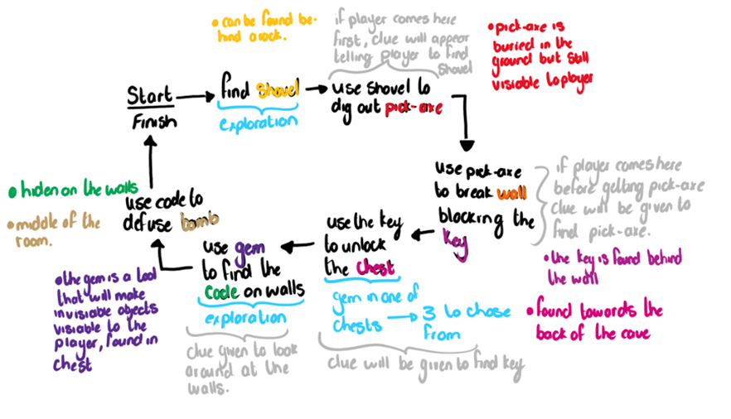

The player progresses through the game by finding clues that will help find the code to defuse the bomb and complete the game.

## Mission/challenge structure

Find the clues to defusing the bomb.

## Objective

Defuse the bomb and escape the mine.

# Mechanics

## Movement

## Objects

Play can interact with objects within the game such as

* Shovel

* Pick-axe

* gems

* Destroyable wall

* Open chests

* key

* bomb

Other objects in the environment

* cart

* numbers on the wall

* rocks

* archway

## Actions

Player can move around the world.

Player can pick up and drops objects.

Player can destroy objects.

Player can interact with objects in the world.

# Story

The miners set a bomb to expand the mine to gain more treasures, but after the miners as set the bomb to go off the miners realise that the entrance is blocked off and they have missed judged to bombs power. The miners also realize that they hide the code around the mine but cannot remember where they hide it. The miners are not on the hunt for the code in order to save themselves.

# Interface

## Visual system

Inset images

## Audio, music, sound effects

Sound effects are placed on certain objects and will increase and decrease in volume when the player is a certain distance from the object.

* The bomb will have a ticking sound
* The mine will emit and airy echoey effect
* The shovel will have a digging sound effect when in use and a sound for when it is picked up
* The pick-axe will have a striking sound when it collides with the wall
* Chest opening sound
* When a player is given a clue a chime sound will occur

# UI

The game will have a computer-based AI that will provide clues the player if they are reaching the objects without the object needed.

* Clues

* + How the clues are displayed in the game

* How to play

* Others

# Game images

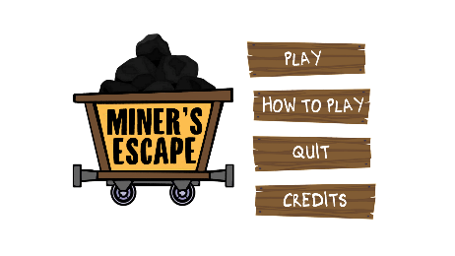

# Credits

* Design Journal

Jade Watermeyer

* Game UI

Zayaanah Albertyn

* Programming and 3D modelling

Keagan Bowler

* Level design and layout

Matthew Brown

* Sound

Provide by Ben

* + Sourced from

Ticking Time Bomb Sound Effect (2017) YouTube video, added by channel “Free Sound Stock.” Available at: <https://www.youtube.com/watch?v=M7LFgAPPhOs>

D&D Ambience Active Mine (2019) YouTube video, added by channel “Michael Ghelfi.’’ Available at: <https://www.youtube.com/watch?v=F6_ZuJSWQ4c&t=857s>

Rolling Cart 02 Sound Effect (2017) YouTube video, added by channel “Sounds Recorded.” Available at: <https://www.youtube.com/watch?v=b7MaejNeMIk>

Correct Ding Sound Effects (2017) YouTube video, added by channel “Motion Array.” Available at: <https://www.youtube.com/watch?v=Uk6Vh1KUkMk>

Pickaxe – Sound Effect (2019) YouTube video, added by channel “Simon Sounds.” Available at: <https://www.youtube.com/watch?v=gHqQIB5sxSs>

Walking on Dirt (2016) YouTube video, added by channel “Sound Effects.” Available at: <https://www.youtube.com/watch?v=29Yz2eG3UZA>

Ratchet Sound Effects (2018) YouTube video, added by channel “All Sounds.” Available at: <https://www.youtube.com/watch?v=Q6gLQrTWQi8>

Shovel Sound Effects (2018) YouTube video, added by channel “All Sounds.” Available at: <https://www.youtube.com/watch?v=WIZtpf5LW-Q&t=54s>

# Outcome

Some errors in the game that will be fixed in future build of the game.

* Incorrect number ordering on bomb code hint
* Incorrect timing of clues
* Player was spawning in the incorrect place, but this was resolved
* Sound not working perfectly- not being called at the right times unsure as to why.

Other then the errors the game works well and clearly represents the idea that the team had for this prototype. As a group we are happy with the outcome.

# Communication

## Discord

Meeting for project discussions

First meeting held on 20/07 start 17:00 end 17:45

* What the game would be
  + Puzzle game
* Theme
  + Escape room
* Location
  + Mine
* Objective
  + Defuse the bomb before time runs out
* Roles for group members
  + Keagan- making the prototype
  + Zayaanah – making the UI and Narrative for the prototype
  + Ben – sound effects for the Prototype
  + Matthew – Level Layout design
  + Jade- Design Document
* Is the prototype doable in time frame?
  + Yes
* Are the members able to complete their assigned work?
  + Yes
* Depiction map of concept of game
  + Refer to figure 1

Second meeting 21/07 start 17:00 end 18:00

* Level design
  + Depicted by Matthew
  + Refer to figure 2
* Sound effects
  + Provided by ben
  + Ticking
  + Background cave
  + Ambiance
  + Chime for clue
* UI for game
  + Provided by Zayaanah
  + Refer to figure 3
* Changes to game
  + Timer from 10 minutes to 5 minutes
* Current game state
  + Fully transparent objects that can be seen with correct corresponding object
  + Player movement
  + Corresponding object for fully transparent object

22/07 third meeting

* Meeting with Erik
  + Good about everything
  + Feels documentation is to extensive
  + Replace some info with image diagrams instead
* Group meeting
  + Discussion of updating current state of game
    - Models completed
    - Majority of game completed
    - No cheats or easter eggs exactly
  + What is left
    - Implementing all assets into the game
    - Might add pause menu
    - How to attach sound object to specific objects

23/04 fourth meeting started 17:00 ended 18:15

* Error with github push result in loss of work.
  + Unclear on how to solve issue
* Project is ready for integration
  + Sound effects
  + Art assets

## WhatsApp

20/07

* Initial project discussions
* When to hold meeting

21/07

* When to hold meeting

22/07

* Asking for UI images
* When to hold meeting

23/07

* When to hold meeting

## GitHub

Prototype sharing

22/07

* Error in implementing art assets, all new work was lost

## Google Docs

Documentation sharing

20/07

Document created and shared with team

21/07

Document updated after meeting

22/07

New layout for documentation

23/07

New documentation after meeting with Erik